**RISK ASSESSMENT TEMPLATE**

|  |
| --- |
| RISK ASSESSMENT SCOPE: |

|  |  |  |  |
| --- | --- | --- | --- |
| Risk Assessment Reference Number / Title: | | | |
| Assessment location: | | | Assessment date: |
| Persons Involved in Risk Assessment (Team) | Signature | | |
|  |  | | |
|  |  | | |
|  |  | | |
| Describe the activity/task/item/product: | | | |
|  | | | |
| Documents referenced (including manufacturers manuals, standards, codes of practice and any relevant legislation): | | | |
|  | |  | |
|  | |  | |
|  | |  | |

|  |
| --- |
| RISK ASSESSMENT MATRIX: |

*(Use this table to determine the risk ratings)*

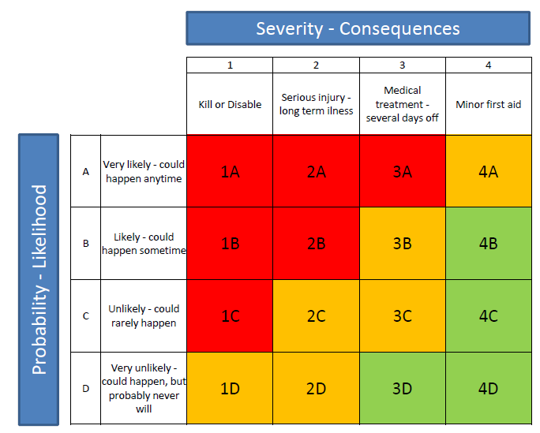

|  |
| --- |
| HIERARCHY OF CONTROLS – TYPES OF RISK CONTROLS: |

*(Aim to implement the highest possible control type)*

Eliminate; Substitute; Isolate; Engineer; Administrative; PPE

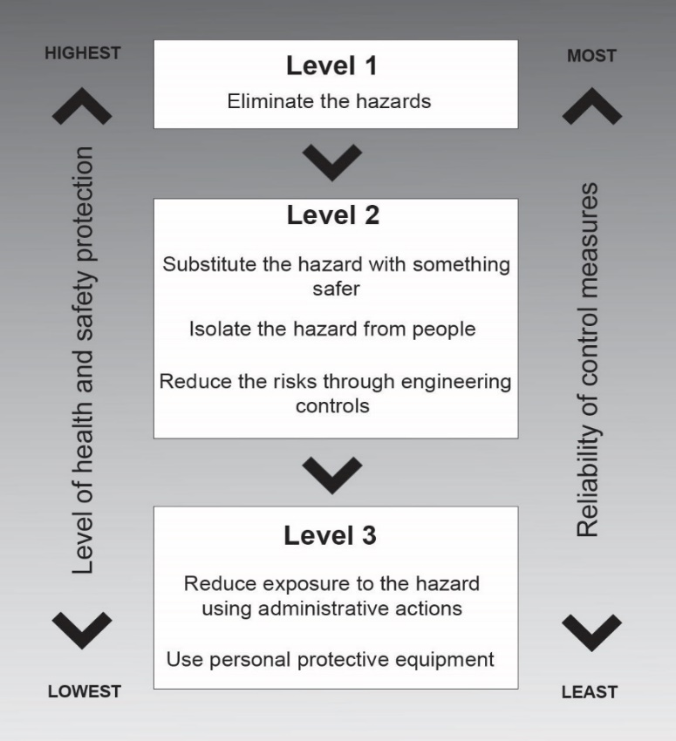

|  |  |  |  |  |  |  |
| --- | --- | --- | --- | --- | --- | --- |
| Haz no. | Hazard description  *(e.g. Wet floor with potential to cause injury from slips/trips/falls)* | Current risk controls  *(e.g. mop the floor)* | Initial risk rating  *(e.g. 3B)* | Proposed risk controls  *(e.g. place wet floor hazard signage)* | Type of risk control  (Hierarchy of controls e.g. Administrative) | Residual risk rating  *(e.g. 3C)* |
| 1 |  |  |  |  |  |  |
| 2 |  |  |  |  |  |  |
| 3 |  |  |  |  |  |  |
| 4 |  |  |  |  |  |  |
| 5 |  |  |  |  |  |  |
| 6 |  |  |  |  |  |  |
| 7 |  |  |  |  |  |  |
| 8 |  |  |  |  |  |  |
| 9 |  |  |  |  |  |  |
| 10 |  |  |  |  |  |  |
| 11 |  |  |  |  |  |  |

|  |
| --- |
| HAZARD IDENTIFICATION AND RISK ASSESSMEMT: |

|  |
| --- |
| RISK CONTROL PLAN (ACTIONS SUMMARY): |

|  |  |  |  |  |  |
| --- | --- | --- | --- | --- | --- |
| Ref No. | Recommended Action | Responsible Person | Target Completion Date | Actual Completion Date | Completion Sign-Off |
| 1 |  |  |  |  |  |
| 2 |  |  |  |  |  |
| 3 |  |  |  |  |  |
| 4 |  |  |  |  |  |
| 5 |  |  |  |  |  |
| 6 |  |  |  |  |  |
| 7 |  |  |  |  |  |

*For each proposed risk control, provide a recommended action and allocate a responsible person and time frame in consultation with that person. Completion confirmation is required for each action.*

|  |
| --- |
| REVIEW: |

| Control measures have been reviewed and no further risks have been identified Yes No | | | Are further reviews required? No Yes When: | | |
| --- | --- | --- | --- | --- | --- |
| Reviewer name: | | Reviewer signature: | | | Date: |
| Record of subsequent reviews. | | | | | |
| Review date: | Reviewed by: | | | Description of any changes: | |
|  |  | | |  | |